1 Corinthians

Chapter 6

This is What you Were

**Worship** (CW:380:2)

**Lesson Objectives**



A: It was grace in Christ that called me,

**B: Taught my darkened heart and mind,**

A: Else the world had yet enthralled me,

**B: To your heavenly glories blind.**

A: Now I worship none above you;

**B: For your grace alone I thirst,**

A: Knowing well that, if I love you,

**B: You, O Father, loved me first.**

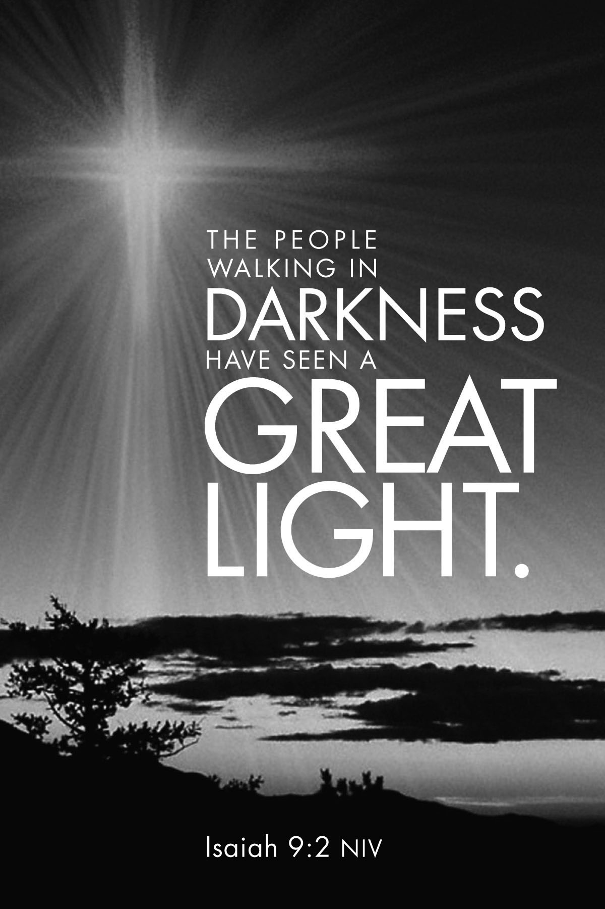**Before We Begin**

What kind of things did you/will you look forward to leaving behind when you moved past each of the following ages:

* Preschool
* Grade school
* High school
* College

**Lawsuits Among Believers (6:1-11)**

1. Paul heard that the Corinthian believers were taking each other to court.
   1. What was the root cause of these actions?
   2. What unintended effect did their actions have on the unbelieving people of Corinth?
   3. Describe how we are sometimes guilty of forgetting that effect in our own lives.
2. Verse 7 says, “Why not rather be wronged? Why not rather be cheated?”
   1. How is our mindset often different than this when dealing with a loved one? With a stranger?
   2. List times you saw verse 7 reflected in the life of Jesus Christ.
3. You see a news report of a celebrity/athlete getting busted for a very public crime. Your first thought is: “What a horrible person!”
   1. How do verses 9 and 10 help us cut off such thoughts?
   2. Why would verse 11 be a great reminder to start each day?

**Sexual Immorality (6:12-20)**

1. Paul makes a list of excuses people were using for sin in his day.
   1. Make a list of excuses we use for sin.
   2. Destroy that list of excuses with truths from Scripture.

**Cast All Your Anxieties on Him…**



1. Discuss how you would teach and apply the following phrases to peer pressure in high school.
   1. Flee from sexual immorality.
   2. Your bodies are not your own; you were bought at a price.

**Review:**

Sin:

New:

Reminder:

Thankfulness: