1 Corinthians

Chapter 3

The Function of the Christian Ministry

**Worship** (CW:538:1)

A: The Church’s one foundation

**B: Is Jesus Christ, her Lord;**

A: She is his new creation

**B: By water and the Word.**

A: From heav’n he came and sought her

**B: To be his holy bride;**

A: With his own blood he bought her,

**B: And for her life he died.**

**Before We Begin**

**Words to Remember**

3:11 For no one can lay any foundation other than the one already laid, which is Jesus Christ.

At your tables: For each of the following situations, discuss what your first reaction would be. Then discuss what your actual course of action would be.

* You’ve been working on a garden all of June and haven’t seen any visible progress
* You’re a high school student and a parent or teacher tells you, “I really expected more out of you. You need to grow up.”
* In the middle of your dentist appointment, your dentist tells you, “Things have gotten worse since I saw you last. Have you been flossing like I told you last time?”

**A Mature View of the Ministry (3:1-9)**

1. Paul calls the Corinthians “worldly” because they were following the wisdom of the world.
   1. 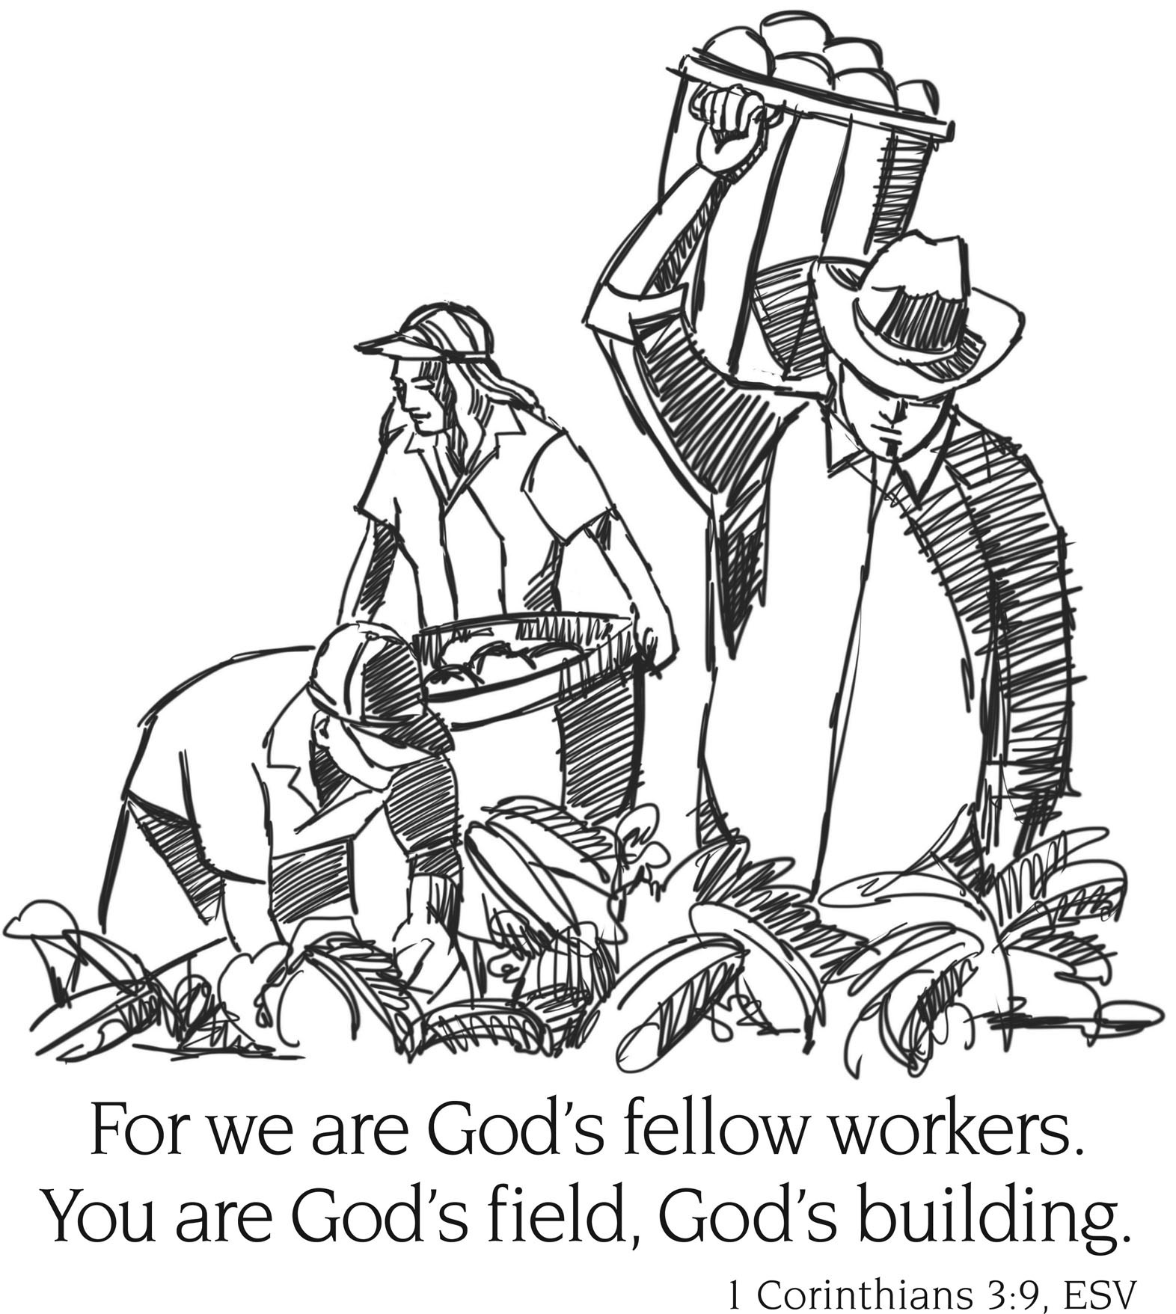What actions of the Corinthians made them look like the rest of the world?
   2. What does this tell you about the relationship between our spiritual maturity and our lives?
   3. Describe how we might find “worldly” thought processes creeping into the following locations:
      1. Our homes
      2. Our workplace/school
2. Paul calls himself a servant in this section.
   1. Describe why we don’t typically like to think of ourselves as a servant. Then discuss what negative things happen as a result of that mindset.
   2. Why is it actually very appealing to think of ourselves as servants with God as our master?
3. God made the plant grow.
   1. What dangers are involved if we forget that for ourselves?
   2. What dangers are involved if we forget that as a church?
   3. What blessings are involved when we remember? When we remember v.8?

**A Sure Foundation (3:10-17)**

1. Look at the following statement: “Teachings and doctrines aren’t that important. They mostly divide and get in the way. What is most important is love.” What would be appealing about thinking that way? How would you respond? (Use verses 12-15 for help.)

**Standards and Ownership (3:18-23)**

1. What is the antidote to the creeping worldliness from question 1? (Verses 18-19)
2. Verses 21-22: “All things are yours, whether Paul or Apollos or Cephas or the world or life or death or the present of the future – all are yours.” What would our sinful nature like to do with this statement? What amazing truth is Paul actually teaching us?

**Review:**

New:  
  
Reminder:  
  
Sin:

Thankfulness: